|  |
| --- |
|  |



**2 November 2012** **The Weekly Bulletin of Rotary Club of Kathmandu Mid-Town** **Bc-2.11/012-13**

District : 3292 Web:www.rotarymidtown.org.np Club Id : 26776

**NOVEMBER IS THE ROTARY FOUNDATION MONTH**

The Rotary Foundation of Rotary International was established in 1917 as an endowment fund. It was named The Rotary Foundation by the 1928 convention. In 1931, it was organized as a trust, and in 1983, it was established as a not for-profit corporation under the laws of the State of Illinois, USA. The Rotary Foundation is operated exclusively for charitable and educational purposes by the Trustees of The Rotary Foundation in accordance with the Foundation’s articles of incorporation and bylaws.

Friday, 19 October:

**Joint meeting with RC Jawalakhel Manjushree.**

Rtn. Pramada Shah, in-house Speaker of RC Jawalakhel Manjushree, while talking on ‘Animal Rights’ presented an enlightening information on the status of domestic animals in Nepal. She called for joint actions for the welfare of animals, their rights and shun away from the tradition of animal sacrifice in the name of religion in Dashain and other festivals. Presenting some activities of BVS-Nepal, she related the change of attitude of Brick Kiln owners towards their donkeys and how this changed the working environment of the production sites. It was interesting to note that BVS-Nepal categorises Brick kilns with green, yellow and red color depending on their treatment towards their donkeys and emphasized on the necessity of awareness towards this aspect.

# Weekly Meetings and Programs :

|  |  |  |
| --- | --- | --- |
| Date | Program/Speaker | Program/Topics of Presentation |
| 2 Nov 2012 | DRFC Rajesh Thapa | The Rotary Foundation |
| 9 Nov 2012 | ?? | ?? |
|  |  |  |

Friday, 2 November:

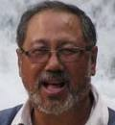

Rtn Rajesh Thapa, District Rotary Foundation Committee Chairperson will be speaking

on basics of The Rotary Foundation, how it has been supporting Rotary Clubs around the

world by providing matching grants to community service projects, its challenges, future

vision grant model and how Rotarians world-wide have been supporting TRF operations/

programs by providing donations in different forms.

**Changa Chait Champion:**

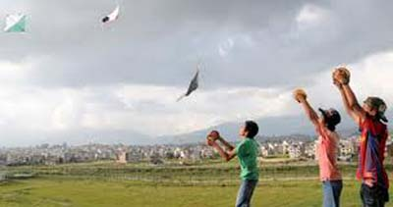 

*On Saturday 20 October 2012 Venue: Tallo Dakshi, Macchegaun VDC-8, Nepal*

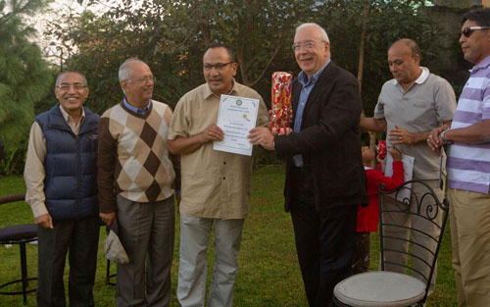

*PE Saroj Shrestha, winner of Changa Chait Champion,*

*receiving Championship certificate from Mid-Towner HE Alexander Spachis.*

*President Devendra and other Mid-Towners present look on.*

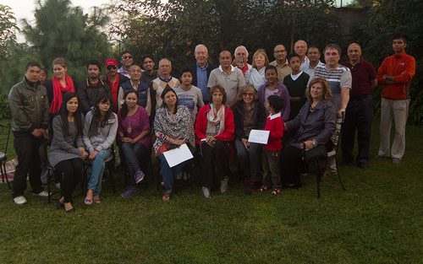

*Group photo on the occasion.*

**RCMV-RCKMT Schooling Project:**

On Monday 15 October a small team of Rotarians (President Devendra, PP Ajay, PP Arun, Rtn Navyo and Rtn Werner) from RC Kathmandu Mid-Town visited the project site, Tistung for distribution of school materials and uniforms to students of Janata Primary School in Palung, Tistung VDC, Makwanpur.

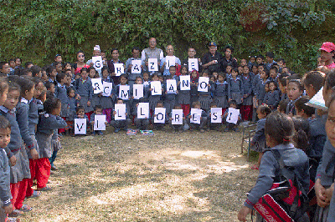

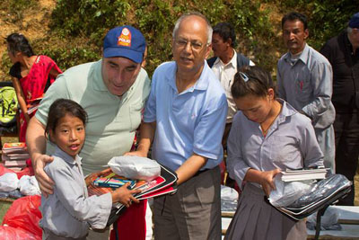

*President Devendra and Rtn Navyo hand over school sets to students*

**The Rotary Foundation:**

Why is Rotary changing its grant model?

Howard Tong, a Rotary public image coordinator and a past district governor, talks about the benefits of The Rotary Foundation’s new grant model, which will be launched in July 2013. The new grant model has many advantages. District grants enable clubs to use Rotary Foundation funds to directly serve their community however they see fit, in line with the Foundation’s mission. Global grants help Rotary clubs and districts partner with one another on large service projects, while packaged grants provide opportunities for Rotarians to work with the Foundation’s strategic partners.

In addition, the new grant model offers:

Simplified processes. Rotarians will be able to apply for, obtain, view the progress of, and complete transactions for their grants online — all strong aspects of the grant model’s efficiency.

More collaboration. Districts and clubs are encouraged to share their expertise and work together on critical issues. For example, a pilot project by districts 9940 (New Zealand) and 9550 (parts of Australia and Timor-Leste) will improve the quality of life for people in Timor- Leste who face life threatening illnesses.

Better stewardship. A memorandum of understanding for grant projects confirms that the right procedures and reporting processes are in place to ensure that best practices are followed.

Increased contributions. Donors who can see the return on their investment are inspired to make more contributions. For example, District 9940 (New Zealand) has experienced a 40 percent increase in Rotary Foundation giving since it began participating in the Future Vision pilot.

Greater impact. Rotarians can find opportunities for sustainable international projects centered on the areas of focus. For example, a club can use a global grant to send a vocational training team to provide health care training to a community in another country, and enable a team of health care workers from the recipient club to travel to the sending club for further training.

The Rotary Foundation’s new Future Vision grant model is currently being tested in a pilot and will become available to all districts in July 2013.

*Source:*Rotary International News

*……the idea of vocational service. It was the idea that through our work, we can*

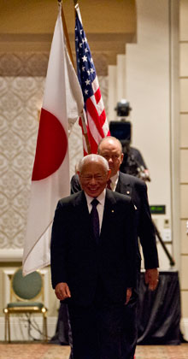

*serve others. We think about others’ needs, and grow to care more for the needs of*

*our communities. We build positive connections between people, and a more*

*peaceful world.*

*This is the idea that has changed my life. It did not change how much I worked, or how hard I worked. But it changed why I worked, and how I experienced my life. It has made me see a higher purpose in everything I do.*

**RI President Sakuji Tanaka**

On Lighter Side :

Click here ⇩



**A THOUGHT FOR THE DAY:**

**Life is like riding a bicycle, to keep your balance you must keep moving.**Albert  Einstein

*courtesy:* Rtn Dr Isabella C Bassingana Khadka

**Great Quotes:**

***Arguing with a fool only proves that there are two !***

**It’s the Door, not Aging!**

Ever walk into a room with some purpose in mind, only to completely forget what that purpose was?

Turns out, doors themselves are to blame for these strange memory lapses.

Psychologists at the University of Notre Dame have discovered that passing through a doorway triggers what's known as an event boundary in the mind, separating one set of thoughts and memories from the next.

Your brain files away the thoughts you had in the previous room and prepares a blank slate for the new locale.

It's not aging, it's the damn door!

Whew, Whooo!  Thank goodness for all those expensive studies  **!!!**

*courtesy:* Rtn Dr Isabella C Bassingana Khadka

**A puzzle:**

*Here are five scrambled words –*

**MEAT, CROSEC, LASTGOOP, BLOTLOAF, LERAPY**

*Rework them out so that they come to original form!*

*Clue : they are all related with one popular sport.*

NB: If you have any information/photo that may be of interest to Rotarians send them to

BC Editor: RR Shrestha email: rryesrr@gmail.com

## 2 Nov 2012 The Weekly Bulletin of Rotary Club of Kathmandu Mid-Town bc-2.11/012-13